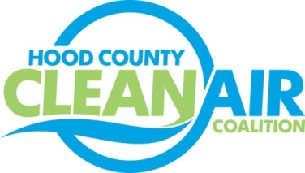
Meeting: Wednesday, October 3, 2018
Cresson City Council Chamber
8901 East U.S. Highway 377 Cresson, Texas 76035
9:00-10:30 a.m.

Agenda

- Call Meeting to Order
- EPA Updates – Randy Pitre, EPA
- Local Updates – Michelle McKenzie
  - Review of July, August, and September Meeting Summaries
  - Review of Projects
    - Monthly Budget Review for June, July, and August
    - Status of Projects
  - Reports
    - September Ozone Update
    - Healthy Children Coalition for Parker County Meeting
    - Air North Texas Meeting
- Regional Updates – Michelle McKenzie
  - New Webpage Part of Fleets for the Future: North Texas SHARE
https://www.northtexassharee.org/SHARE partners/available-contracts-2
  - DFW Clean Cities Events: https://www.dfwcleancities.org/dfw-clean-cities-meetings
    - Propane Autogas Lunch and Learn- October 30
    - Texas Natural Gas Vehicle Road Rally Luncheon- November 2
  - Funding Opportunities: www.nctcog.org/aqfunding
- Other Discussion
- Adjourn

